ADa – Star Schema

For the model below:
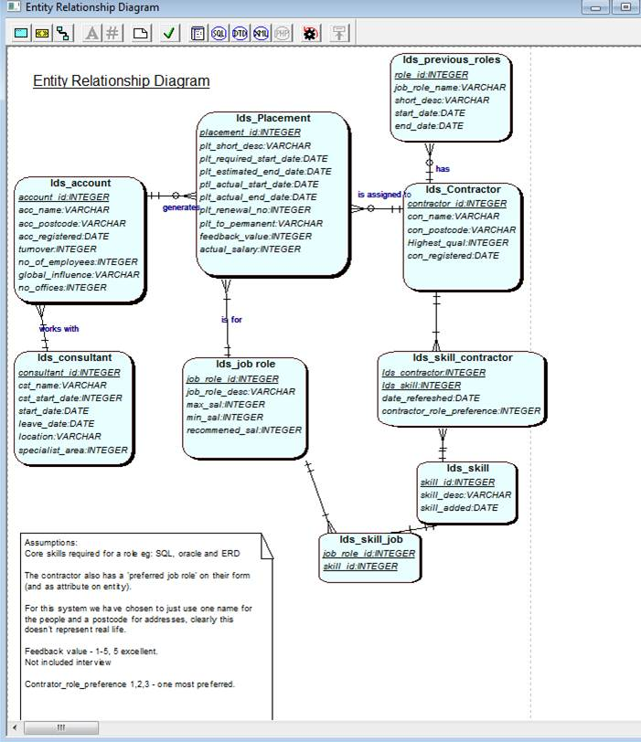

List 3 queries that an investor in PlaceIT may want to know (base this on the assessment KPI’s)
1.………………………………………………………………………………………………………………
2………………………………………………………………………………………………………………
3.………………………………………………………………………………………………………………

Star Methodology (consider using this for your assignment…)

List & clarify relevant business question(s) that need to be answered for the Investor

What Dimension tables are required (name them eg time_dim)

Identify lowest level of granularity (for each Dimension)

Identify the measures to support the business questions (calculations or facts)

Define (name, data type) suitable attributes of the Dimension tables

Define (name, data type) the Fact table (keys and measures)

Draw the Star Schema (using QSEE) and create a table (in notepad) to illustrate the data for each table in the star schema.

Create a data dictionary to document each of the tables in the star schema model.
Show where each piece of data in the star schema comes from (from the PlaceIT and Search4U systems), describe mappings and transformations.

Research data dictionaries and add to the data dictionary metadata that would be valuable.

Now, reconsider the tasks done above to include Search4U data source.

